1)

import java.net.*;

import java.io.*;

public class EServer

{

public static void main(String args[])

{

ServerSocket s=null;

String line;

DataInputStream is;

PrintStream ps;

Socket c=null;

try

{

s=new ServerSocket(9000);

}

catch(IOException e)

{

System.out.println(e);

}

try

{

c=s.accept();

is=new DataInputStream(c.getInputStream()); ps=new PrintStream(c.getOutputStream());

while(true)

{

line=is.readLine();

ps.println(line);

}

}

catch(IOException e)

{

System.out.println(e);

}

}

}

Client

import java.net.*;

import java.io.*;

public class EClient

{

public static void main(String arg[])

{

Socket c=null;

String line;

DataInputStream is,is1;

PrintStream os;

try

{

InetAddress ia = InetAddress.getLocalHost();

c=new Socket(ia,9000);

}

catch(IOException e)

{

System.out.println(e);

}

try

{

os=new PrintStream(c.getOutputStream());

is=new DataInputStream(System.in);

is1=new DataInputStream(c.getInputStream());

while(true)

{

System.out.println("Client:");

line=is.readLine();

os.println(line);

System.out.println("Server:" + is1.readLine());

}

}

catch(IOException e)

{

System.out.println("Socket Closed!");

}

}

}

2)Network commands

i) ping

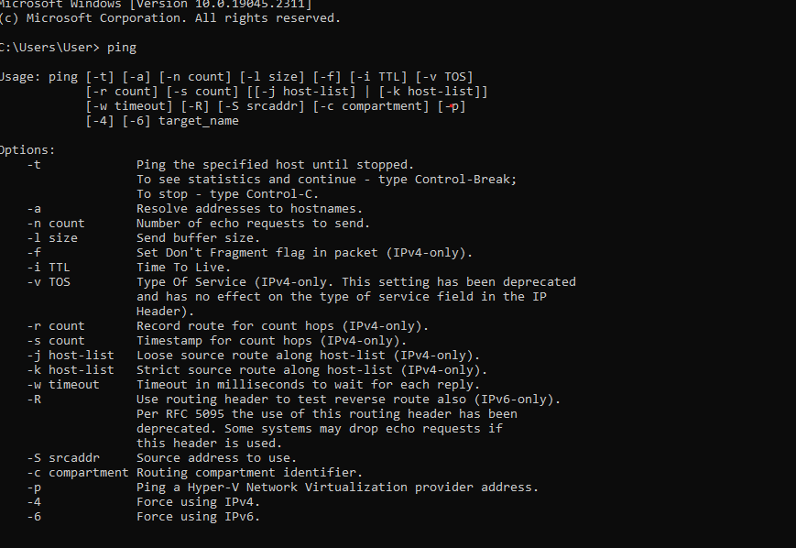

ii) netstat _p

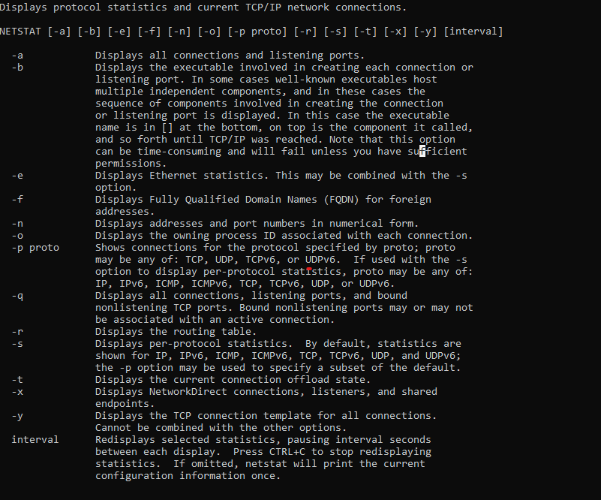

iii) ipconfig

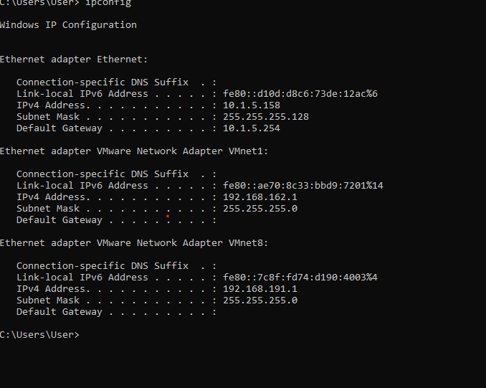

iv) nslookup

v) nslookup

